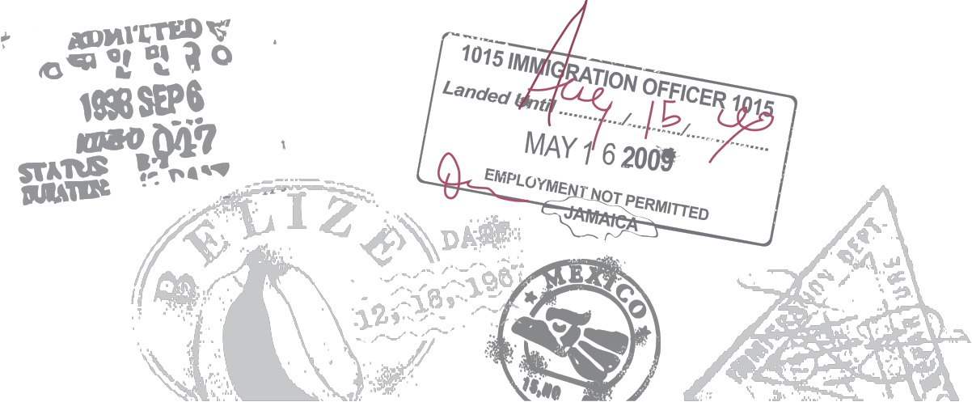Sponsorship
Opportunities

Captain’s Circle ............... $1,250
This level of support includes Presenting the Best of Show, 4 tickets to the event and your company prominently featured at the event, on the website and in all collateral material.

Diamond Member ........... $1,000
This level of support includes 2 Tickets to the event and your company prominently featured at the event, on the website and in all the collateral material.

Platinum Member .............. $750
This level of support includes a dinner ticket and company listing on all collateral material and on the website.

Gold Member ...................... $500
This level of support includes recognition at the event, on the website and all collateral material.

Silver Member .................... $250
This level of support includes recognition at the event, on the website and all collateral material.

